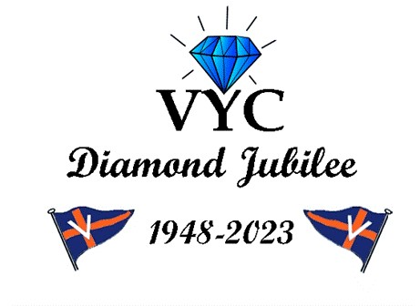

Virginia Yacht Club

2023 Closing and Change of Watch October 5, 6, and 7

**“Diamonds are Forever”**

# Thursday, October 5

5:30 – Pot Luck Dinner, bring a dish to share 7:00 – Movie – “Diamonds are Forever

# Friday, October 6

Arrivals, visit with VYC friends, lunch on your own, shop the VYC Boatique

12:00 – Bridge Luncheon

5:30 – 6:30 VYC Cocktails and appetizers

6:30 – 7:30 Ernst Stavro Blofeld Octoberfest Dinner by Willaby’s

7:30 – Recognize the “VYC Distinguished Diamonds” of the 2022-2023 Diamond Jubilee Year

Attire is casual

# Saturday, October 7

VYC Boatique open

8:30 – 9:30 Coffee and light breakfast in the clubroom

10:00 – 12:00 Special team events

Lunch on your own

5:00 – 6:00 VYC Cocktails and appetizers on the porch

6:00 – 6:30 VYC Annual Business Meeting

6:30 – 7:30 Dinner by Willaby’s

7:30 Reconvene Annual Meeting and Change of Watch Ceremony – Salute the 2023-2024

Bridge

Attire – Bridge Uniform for Officers and Past Commodores (grey slacks, white shirt, blue blazer, VYC crest and VYC tie); all others coat and tie or cocktail attire.

# Sunday, October 8

Depart for home ports – safe travels until we meet again!

Marina Reservations: Call Regatta Point Yachting Center at 804-776-8400 as soon as possible.

# PLEASE NOTE RESERVATION POLICY

Slip cancellations must be made 4 days before your scheduled arrival date or 1 day’s dockage will be charged per a May, 2022 agreement between VYC and Regatta Point.